DFS

Acme have tasked me with creating a Distributed File System (DFS) namespace for their 4 departments, being Sales, Marketing, Finance and Support. This allows users within these departments to have easier access to the shared folders that are stored on separate servers.
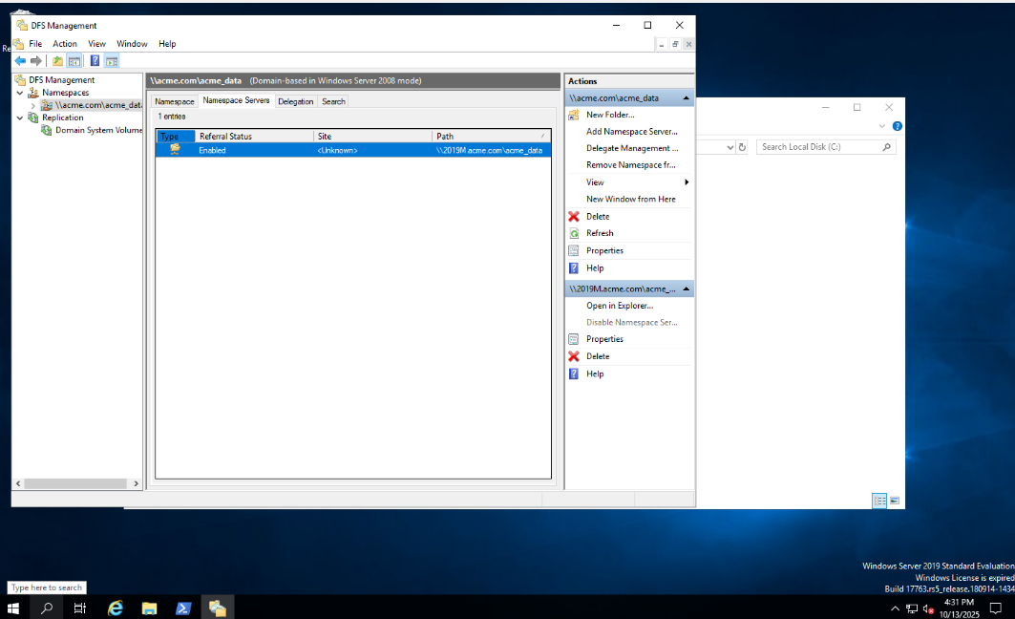
The screenshot shows the DFS namespace being configured for Acme’s data. This shows the space that the Sales, Marketing, Finance and Support departments will be able to access. The namespace allows the departments shared centralized access to servers that are otherwise separate for each department.

Fig 1.
The DFS namespace server is set up

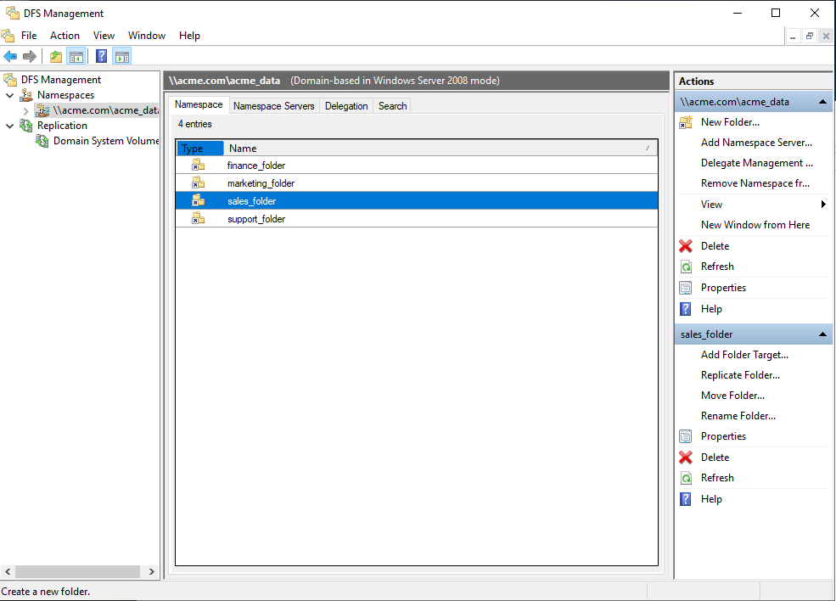

Fig 2.
The folders are configured for the 4 departments

The screenshot shows the Acme departments separate folders that are configured within the DFS namespace. These folders include Sales, Marketing, Finance and Support. This allows each department to access their respective folders in an easy simplified way despite the fact that each department physically has their own separate server.

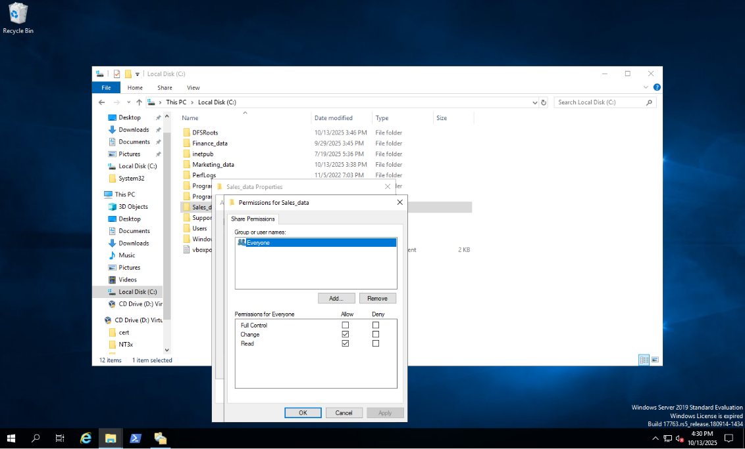
The screenshot shows the permissions being configured for the sales data folder, to represent that the same was done for all 4 department folders. The users were given change and read permissions on their folders so they can view, access and alter the contents of their folders. This allows for the right level of access for each department spread across both offices to work collaboratively.

Fig 3.
The permissions are configured for the 4 departments folders

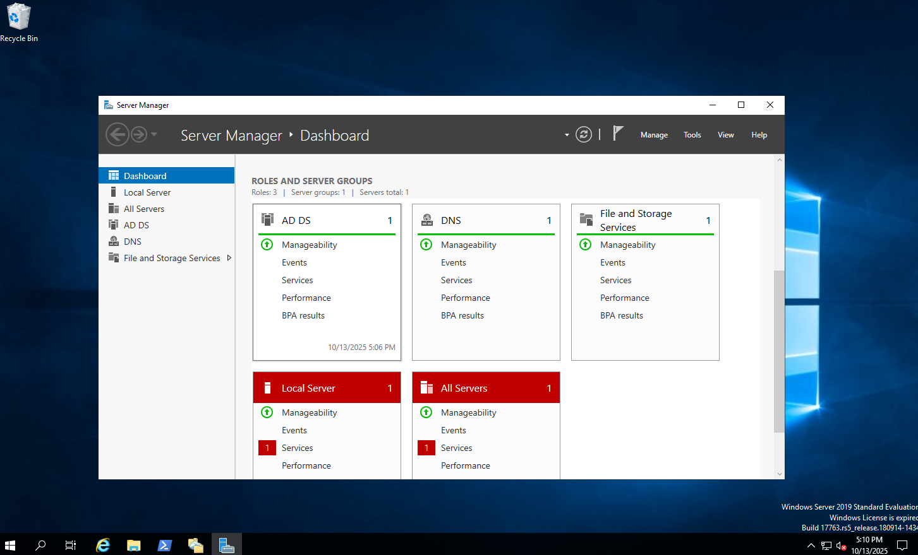

After completing the work tasked to me by Acme, I would more than likely need to configure further permission and security settings on each of the folders. This would include enabling access based enumeration, meaning that users would only be able to see, access and alter the folders that are made for their departments. For example, the marketing department would have either no access or read only access to the sales department folders. This allows for an increased level of security across the company. I could also optimize namespace polling. This would often the namespace retrieves updated information from Active Directory, either optimizing for consistency or scalability, which helps an issue Acme has as they said Active directory was not suitable as it wasn’t scalable for the size of the company, therefore resulting in them using a DFS namespace.

The screenshot shows the DFS role being installed within the server manager. This allowed me to actually group the shared folders across the different departments that are stored on individual servers and put them into a unified space for the 160 employees to access from two locations, allowing for a more organized view for the employees

Fig 4.
The DFS role is installed in Server Manager

Reference List:
Microsoft, 2025, DFS Namespace Overview [Accessed October 2025], source: https://learn.microsoft.com/en-us/windows-server/storage/dfs-namespaces/dfs-overview?tabs=server-manager
Microsoft, 2024, Checklist: Tune a DFS Namespace [Accessed October 2025]. Source: https://learn.microsoft.com/en-us/windows-server/storage/dfs-namespaces/checklist-tune-a-dfs-namespace
Moran,D, 2022, How to setup a DFS Namespace (Distributed File System) [Accessed October 2025], source: https://www.youtube.com/watch?v=XGmxZNRTrgY
Naviko Team, 2023, What is DFS Replication and how to configure it [Accessed October 2025], source: https://www.nakivo.com/blog/configure-dfs-replication-for-windows-server/
Lee,B, 2024, DFS replication: requirements and configuration [Accessed October 2025], source: https://www.bdrshield.com/blog/distributed-file-system-dfs-windows-server-2016-brief-overview/

Configuring IP Addresses
XYZ have tasked me with configuring IP addresses for their servers and workstation interfaces. They have 4 departments, being sales, marketing, finance and support and they have implemented a Linux based network. This is particularly useful as this will allow their workstations and server to be discoverable and allow the departments to communicate with each other on the network.

Fig 1. Bridged Adapter

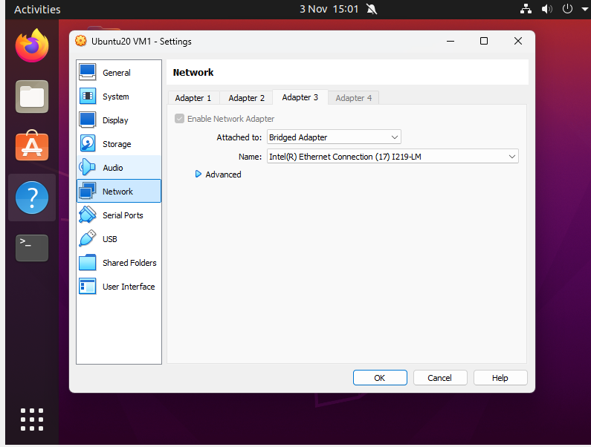
In this screenshot, I am checking which adapter is the bridged adapter as this is where I want to configure the IP address. In this case, it’s the third adapter. This will help all the devices communicate with each other on the network and it allows the host machine to communicate with these devices as well. As a result, this means the bridge can very easily be remotely managed or can act as a default gateway, allowing all of the IP addresses on workstations within XYZ to be automatically configured in the network, allowing for communication between the devices and the host machine as well.

Fig 2. Using Netplan

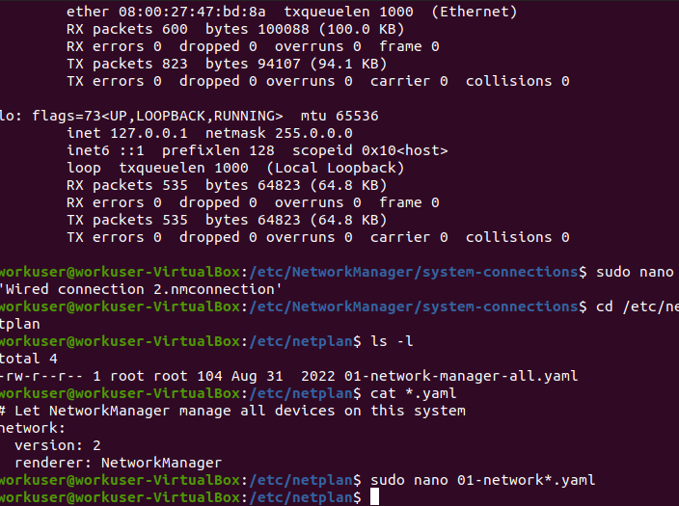
Fig 3. Dynamic Address Config

In this screenshot, I use Net plan to translate the contents of the yaml file into network settings. I checked the contents of the file so that I know what needs to be edited and configured within the file to generate the necessary configurations for the renderer. This is helpful in XYZ’s case as this will help in managing the network configurations across their several workstations and their server. As a result, it allows for added simplicity as in the case of any errors, Net plan allows for the network configurations to be read and understood very easily by anybody and allows for simple integration into XYZ’s new Linux based network

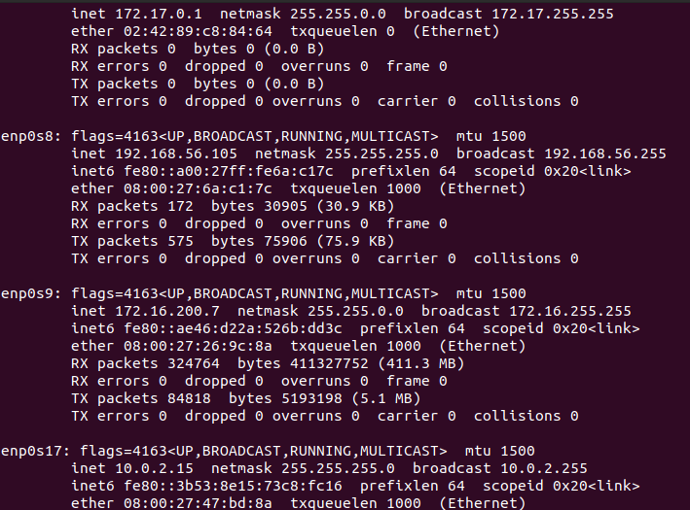
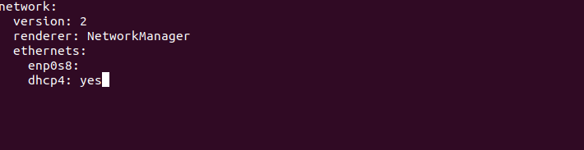
Fig 4. Static Address configured

This screenshot shows me configuring and editing the Dynamic address configuration within the Net plan yaml file. This is useful for XYZ as this is the backend of how their workstations will be configured as this file will be what is applied by the backend renderer ,Network Manager, and is how the static IP addresses will be configured remotely. This simple file is also easily interpretable by both the machines and by anybody who needs to access it, helping create a very versatile and efficient network configuration process as all their workstations and servers can be configured very easily, despite the fact that there are around 100 to configure.

After configuring the static IP addresses, I would need to verify connectivity within the network and ensure all the devices can connect to the network and the internet and communicate with each other. This can be done very easily with the ping command or by browsing a website and ensuring everything works properly. I would also need to ensure the IP is outside the routers range used in its DHCP. This would be to avoid any conflicts with the other devices on the network. This can be easily resolved by using a DHCP reservation next time to assign the IP to the devices MAC address and ensure it doesn’t get assigned by the DHCP to another device. Further best practices would be to keep a document of which devices have static IP’s and their addresses and to perform regular audits on the network to ensure there aren’t any conflicts.

In this screenshot, I’ve fully configured the static IP address for enp0s8, which is the interface for the adapter that I’ve configured within these screenshots. This is helpful for XYZ because it shows the final stage of how the IP addresses will be configured for their workspaces and server within the Linux network. This shows how their devices will be consistently identifiable and accessible within their network due to the fact that they specify a static IP address. This helps XYZ further understand how their workstations will be configured and how easy and efficient it makes communication and access across their network.

Reference List:
WebHostingUK, 2025, How to configure a Network and Set a static IP address in Linux, [Accessed Nov 2025], source: https://www.webhosting.uk.com/kb/how-to-configure-a-network-and-set-a-static-ip-address-in-linux/
Bilanoski,D, 2024, How to configure static IP address in major Linux distributions (the complete guide) [Accessed Nov 2025], source: https://medium.com/@dbilanoski/how-to-configure-static-ip-address-in-major-linux-distributions-the-complete-guide-34b47660bced
CBT Nuggets, 2021, How to configure IPv4 on Linux, [Accessed Nov 2025], source: https://www.youtube.com/watch?v=e-nXk95W7dg
Hira, Z, 2023, Setting a static IP in Ubuntu- Linux IP addressing tutorial, [Accessed Nov 2025], source: https://www.freecodecamp.org/news/setting-a-static-ip-in-ubuntu-linux-ip-address-tutorial/
LearnLinuxTV, 2024, How to use the IP command in Linux: A beginners guide [Accessed Nov 2025], source: https://www.youtube.com/watch?v=wHfIFZlDxtU
NetSecProf, 2025, Configuring a Static IP address from the command line on Ubuntu Linux using Netplan, [Accessed Nov 2025], source: https://www.youtube.com/watch?v=WrTobE-KUPw

Bash Scripting

This screenshot shows the user interface after it has been fully configured. This is the screen that the user will be presented with at first to prompt the user to choose an option, which is either to back up a folder, show files in the backup or restore a file. This helps fully automate and simplify the process for XYZ, as specified in the brief, as this is something that can be easily integrated into their Linux based network.

Fig 2. Backing up the files

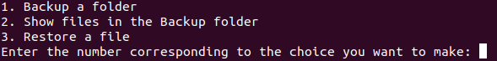
Fig 1. User interface

XYZ have tasked me with creating a Bash Script that will back up folders on their server to automate some of the administration within their company. They want to user to be presented with a User interface that allows them to do 1 of three options: backup a folder, list the files in the backup folder and restore a file from the backup folder. XYZ would like me to configure this for their 4 departments, which are Sales, Finance, Marketing and Support

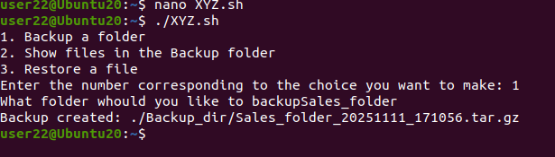
Fig 3. Showing files in backup folder

This screenshot shows if the user were to choose option 1, which is backing up a folder to a specified file as a tar.gz file. The brief also specifies that the target filename should include the date, which I have done as this distinguishes the file from other backups with the same or a similar filename. This helps all the employees and departments more efficient when it comes to backing up files as everything is more ordered and automated in a quick and easy process due to the specification of the path and the date being implemented automatically into the filename

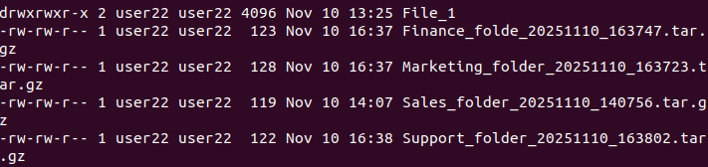
This screenshot shows if the user enters option 2, which is to display a list of files within the backup folder. This is particularly useful to XYZ as they can ensure that the files have been backed up in the proper manner, with the correct filenames and in the correct directory. Due to the fact that all departments have access to this, all of them can see what has been backed up and when in a very simplified and straightforward process.

Fig 4. Restoring a file

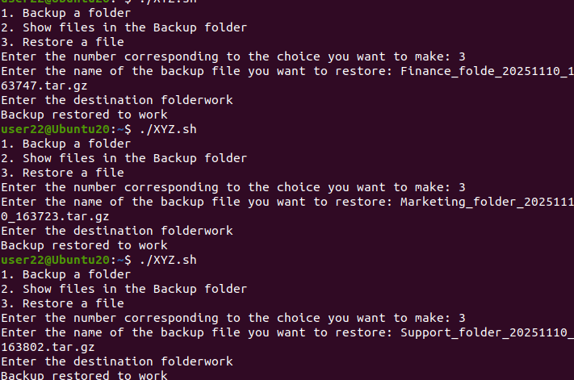

This shows if the user were to choose option 3, which is to restore a file back to the destination folder that’s specified by the user. Here the script automates the process in a simplified way for all of their departments, and this can be easily integrated within their new network. This allows users to very easily move files in and out of the backup folder without having to access any scripts or enter any commands themselves, making it easier for employees to manage the administration.

Fig 5. The bash script

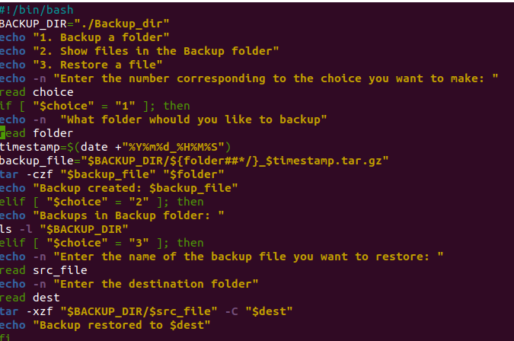
This screenshot shows the back end of the bash script and how it has been configured for XYZ. The script utilizes and relies on if conditioning statements to create the process of allowing users to choose which option they require. This includes all of the specifications for XYZ and everything they required to make the process of automating backing up files within their company. This is particularly useful in the instance that XYZ need to make changes in the future to the program or if they encounter any specific errors as this details and shows everything that runs within the program.

After configuring the script for XYZ, I feel the script would need several improvements to make it more efficient and tailored further for XYZ’s needs. Firstly, I feel that the script could be implemented with error detection to keep the users from entering something that would not make sense, such as backing up a file that doesn’t exist. This could easily make the program much more efficient and makes it easier for the employees. The program could also use more conditioning to make it more visually appealing or easier to understand for the employees, such as a more refined user interface. This would make the process easier to understand for XYZ’s employees and makes the whole process more simplified.

Reference List:
Reynolds,L, 2025, Bash Scripting Tutorial: How to write a bash script [Accessed Nov 2025], source: https://linuxconfig.org/bash-scripting-tutorial
Hira, Z, 2022, Shell Scripting for beginners – How to write bash scripts in Linux [Accessed Nov 2025], source: https://www.freecodecamp.org/news/shell-scripting-crash-course-how-to-write-bash-scripts-in-linux/
Moo, 2021, Bash Scripting for Dummies [Accessed Nov 2025], source: https://medium.com/geekculture/bash-scripting-for-dummies-5d855cbada66
GeeksForGeeks, 2025, Bash Scripting – Introduction to Bash and Bash Scripting, [Accessed Nov 2025], source: https://www.geeksforgeeks.org/linux-unix/bash-scripting-introduction-to-bash-and-bash-scripting/
FreeCodeCamp, 2023, Bash scripting tutorial for beginners, [Accessed Nov 2025], source: https://www.youtube.com/watch?v=tK9Oc6AEnR4

